California Department of Fish and Game
Agency Report
to the
Technical Subcommittee
of the
Canada-United States Groundfish Committee

April 2008

Contributors:
Joanna Grebel
Diane Haas
Sean Hoobler
Kon Karpov
Traci Larinto
Bob Leos
Scot Lucas
Caroline Mcknight
David Osorio
Elizabeth Pope-Smith
Mike Prall
Connie Ryan
Jason Vasques

Edited by:
Traci Larinto
California Department of Fish and Game
Marine Region
4665 Lampson Avenue, Suite C
Los Alamitos, CA 90720
A. AGENCY OVERVIEW

Within the California Department of Fish and Game (CDFG), the Marine Region is responsible for protecting and managing California's marine resources under the authority of laws and regulations created by the State Legislature, the California Fish and Game Commission (CFGC), and the Pacific Fishery Management Council (Council). The Marine Region is unique in the CDFG because of its dual responsibility for both policy and operational issues within the State's marine jurisdiction (0 – 3 miles). It was created to improve marine resources management by incorporating fisheries and habitat programs, environmental review, and water quality monitoring into a single organizational unit. In addition, it was specifically designed to be more effective, inclusive, comprehensive, and collaborative in marine management activities.

The Marine Region has adopted a management approach that takes a broad perspective relative to resource issues and problems. This ecosystem approach considers the values of entire biological communities and habitats, as well as the needs of the public, while ensuring a healthy marine environment. The Marine Region employs approximately 200 permanent and seasonal staff that provide technical expertise and policy recommendations to the CDFG, CFGC Council, and other agencies or entities involved with the management, protection, and utilization of finfish, shellfish, invertebrates, and plants in California’s ocean waters.

B. MULTISPECIES STUDIES

1. Research and Monitoring

(a) Commercial Fishery Monitoring
Statistical and biological data from landings are continually collected and routinely analyzed by CDFG to provide current information on groundfish fisheries and the status of the stocks. California’s primary commercial landings database is housed in CDFG’s Commercial Fisheries Information System. Outside funding also enables California fishery data to be routinely incorporated into regional databases such as Pacific Coast Fisheries Information Network (http://www.psmfc.org/pacfin).

Contributed by Bob Leos (831.649.2889)

(b) Recreational Fishery Monitoring
The California Recreational Fisheries Survey (CRFS) began in January 2004 to provide catch and effort estimates for marine recreational finfish fisheries. The CRFS generates monthly estimates of total recreational catch for four modes of fishing (beach/bank and shore, piers and jetties, commercial passenger fishing vessels, and private vessels launched from public launch ramps) for six geographic districts along California’s 1,000 plus miles of coast. The data are used by state and federal regulators to craft regulations to protect fish stocks and provide recreational fishing opportunities. The sampling data and estimates are available on the Recreational Fisheries Information Network (http://www.recfin.org).

The CRFS is a multi-part survey which uses field sampling and telephone surveys. In 2007, approximately 45 samplers worked to gather the field data. The CRFS samplers interviewed more than 98,000 anglers at 414 sites, and examined almost 194,000 fish. The licensed angler telephone survey completed almost 26,000 interviews in 2007 which is comparable to the number completed in 2006.

A review of the first three years of CRFS data was undertaken in 2007 to improve the analyses and estimation procedures. This resulted in changes to the number of trip types, the district boundaries, and effort estimation procedures. In 2008, the CRFS program will begin to conduct studies to verify the estimates of effort for night fishing and for boats that depart from and return to private marinas. For more information, go the CDFG’s Marine Region website: http://www.dfg.ca.gov/marine/crfs.asp.

As a condition of their fishing permit, operators of commercial passenger fishing vessels are required to submit a record of their fishing activities on a log provided by the CDFG. The operators must complete and submit a log of each fishing trip. Each log documents the target species, the fishing method, the type of bait, the number and type of fish landed or released, the number of anglers and hours fished, and the location where most of the fish were caught. In 2007, more than 29,000 logs were received by CDFG and processed. The database is maintained in CDFG’s Commercial Fisheries Information System.

Contributed by Connie Ryan (650.631.2536)

(c) In-season Monitoring
The CFGC has authority under state law to manage nearshore species (as defined by the state’s Marine Life Management Act and the Nearshore Fisheries Management Act). The CFGC has given CDFG the authority to take action as a routine management measure to close the recreational and/or commercial sectors of the cabezon, California sheephead, and greenling fisheries upon projected attainment of their respective established optimum yields and fishery allocations. The CDFG also has authority to make in-season trip limit adjustments to the commercial fisheries for cabezon, California sheephead, and greenlings. In 2006 and 2007, the CDFG made in-season adjustments to the commercial cabezon fishery. The September-October cumulative two-month trip limit was reduced from 900 pounds to 200 pounds per nearshore permit holder, allowing the fishery to remain open for the year rather than closing early, which had occurred in the two previous years. Currently, in-season monitoring is used to track landings against statewide total allowable catches, statewide and/or regional allocations, and trip limits.

The CDFG has additional authority to take in-season action to modify management measures or close the recreational fishery for groundfish if harvests are projected to exceed or be well below federally-established harvest guidelines. This authority was exercised in September 2007 to conform to the federal action that closed the recreational fishery in the Northern (Oregon border to the 40°10’ North latitude line located just below Cape Mendocino) and North-Central Groundfish Management (40°10’ line to Pigeon Point at 37°11’ North latitude) areas effective October 1, 2007 due to unanticipated high catches of yelloweye rockfish, a federally-designated “overfished” species.

In-season monitoring of California commercial nearshore species landings is now conducted by CDFG biologists in the areas north and south of the 40°10’ line. South of Pigeon Point, monitoring is further delineated at Lopez Point (36°00’ North latitude) and Point Conception (34°27’ North latitude). This work is done in conjunction with in-season monitoring, management, and regulatory tasks conducted by the Council. CDFG biologists are currently analyzing landings data and evaluating alternative two-month trip limits for the nearshore fisheries, north and south of the 40°10’ line, in preparation for the 2009-2010 regulatory management cycle. The take of minor nearshore rockfishes between the Oregon border and the 40°10’ line may also be specifically addressed. Since 2005, the fishery has exceeded the federal harvest guideline limits in this area primarily due to the take of blue rockfish. Various options are being explored regarding the black and blue rockfish trip limit structure for the Northern management area. Additionally, work has begun on more in-depth monitoring and analyses of the associated bycatch of yelloweye rockfish. This is a stock of special concern for both the commercial and recreational sectors since it is a key constraining species in the take of other rockfish species.

Contributed by Bob Leos (831.649.2889)

(d) Study on the Effects of Allowing Limited Entry Trawl Permit Holders to Fish Fixed Gear
Exempted fishing permits issued by the federal National Marine Fisheries Service (NMFS) allow the permit holders to conduct experimental fisheries that are exempt from annual fishing regulations. The Nature Conservancy and Environmental Defense Fund (co-sponsored by CDFG) submitted an application for an exempted fishing permit to allow a harvesting cooperative (using limited entry trawl permits) to test hook-and-line and trap gears in central California to target groundfish, primarily sablefish. This exempted fishing permit was recommended by the Council.

Contributed by Joanna Grebel (831.649.2804)

(e) Cooperative Research and Assessment of Nearshore Ecosystems (CRANE)
In 2004, The CDFG and nine partners (including universities and other government agencies) completed a cooperative sampling effort to provide information for managing California’s nearshore rocky reef fish and invertebrate populations. This information was gathered for fishery management purposes as well as to evaluate rocky reef ecosystems as a whole. Specifically, the objectives of CRANE were to 1) estimate the density of nearshore fish and invertebrates that are subject to fisheries, 2) measure the size structure of these populations, and 3) measure habitat and ecosystem components that can be associated with changes in density and size distributions over space and time.

Divers surveyed depths from 6 to 20 meters. A subset of the sites was surveyed to a depth of 100 meters using remotely operated vehicles (ROVs). The report documenting the snapshot scuba effort and the results from sampling 88 sites in 2004 was released in 2006. The same report also reviews historical abundance and size information from select sites.

With funding from the Coastal Impact Assistance Program, the 2004 CRANE study provided a unique opportunity for several groups of researchers to survey a broad segment of the California coastline over a relatively short period of time. The CRANE sampling protocol has been integrated into the monitoring program for Marine Protected Areas (MPAs) in the northern Channel Islands. In addition, data collected by CRANE was used in the Marine Life Protection Act (MLPA) process in central California (see sections D.1. and D.2. of this report).

From 2005 through 2007, sampling activites by a subset of the original collaborators focused on density measurements and size frequency of nearshore fish and invertebrate populations at select locations. These locations were primarily inside and outside of established MPAs at the Channel Islands and in areas of the central coast where MPAs are being considered. In 2008, the State’s Ocean Protection Council in coordination with CDFG, is providing funding for a study similar in scope , but smaller in size than the original 2004 CRANE effort.

Contributed by Dave Osorio (831.649.7195)

2. Management

(a) 2007 State Management Measures Affecting Groundfish
The following management measures were continued as status quo. These management measures are designed to limit catches of “overfished” cowcod, bocaccio, canary, darkblotched, widow, and yelloweye rockfishes.
- Commercial status quo measures:
- The boundaries of the trawl rockfish conservation area (RCA) closure north of the 40°10’ line remained at 75 – 250 fathoms for two-month management periods 1, 2 and 6; 75 – 200 fathoms for periods 3 and 4; and, 100 – 200 fathoms during period 5.
- The boundaries of the trawl RCA closure south of the 40°10’ line remained at 100 – 150 fathoms year-round, except between the 40°10’ line and Pt. Reyes (38°00’ North latitude) for periods 1 and 6 where a modified boundary of 100 – 200 fathoms continued.
- The boundaries of the non-trawl RCA closure north of the 40°10’ line remained at 30 – 100 fathoms year-round.
- The boundaries of the non-trawl RCA closure south of the 40°10’ line remained at 30 – 150 fathoms between the 40°10’ line and Pt. Conception, and 60 – 150 fathoms south of Pt. Conception year-round.
- The season lengths for groundfish in waters off California remained the same as for 2006.

- Recreational status quo measures for groundfish including rockfish, lingcod, cabezon, greenlings, and associated state-managed species (rock greenlings, California sheephead, and ocean whitefish) included season length and depth/area closures with exceptions for fishing for sanddabs and “other flatfish”:
- Northern Groundfish Management Area (Oregon border to the 40°10’ line):
- Season length²: Open May through December; open May through November for lingcod.
- Depth restrictions: Fishing allowed shoreward of the 30 fathom contour line May through December.
- North-Central Groundfish Management Area (40°10’ line to Pigeon Pt.):
- Season length: Open June 1 through November 30
- Depth restrictions: Fishing allowed shoreward of the 30 fathom contour line June through November.
- South-Central Groundfish Management Area (Pigeon Pt. to Pt. Conception):
- Season length: Open May 1 through November 30
- Depth restrictions: Fishing allowed shoreward of the 40 fathom contour line May through November.
- South Groundfish Management Area (Pt. Conception to U.S./Mexico border):
- Season length: Open March through December for rockfish, cabezon and greenling. Open April through November for lingcod. Open year-round for California scorpionfish.
- Depth restrictions: Fishing allowed shoreward of the 60 fathom contour line March through December.
- Cowcod Conservation Areas (in federal waters near San Diego):
- Season length: Open March through December for nearshore rockfish, cabezon, greenling, ocean whitefish, and California sheephead. Open April through November for lingcod. Open year-round for California scorpionfish.
- Depth restrictions: Fishing allowed in waters less than the 20 fathom contour line.

Contributed by Joann Graebel (831.649.2804)

(b) Nearshore Management
In 2002, the CFGC adopted the State’s Nearshore Fishery Management Plan (FMP) for 19 species (black, black-and-yellow, blue, brown, calico, China, copper, gopher, grass, kelp, olive, quillback, and treefish rockfishes; cabezon; kelp and rock greenlings; California scorpionfish; California sheephead; and monkeyface prickleback). All but California sheephead, rock greenling and monkeyface prickleback are also included in the Council’s federal Groundfish FMP. The Nearshore FMP is based on a framework management approach that gives the CFGC a comprehensive management strategy to prevent overfishing, rebuild depressed stocks, ensure conservation, promote habitat protection and provide for non-consumptive uses.

The CFGC adopted seasonal closures, total allowable catch, and trip limits for cabezon, kelp greenling, and California sheephead. Additionally, the CFGC provided CDFG with authority to close any of these fisheries upon attainment of the total allowable catch. Seasonal closures coincide with federal groundfish closures in waters off the state of California.

Contributed by Traci Larinto (562.342.7111)

(c) Restricted Access for Nearshore Fisheries
The State of California began a restricted access program for the commercial nearshore fishery in 2003. The Nearshore Fishery Permit is required to take 10 shallow nearshore species: black-and-yellow, gopher, kelp, China, and grass rockfishes, kelp and rock greenlings, California scorpionfish, California sheephead, and cabezon. The Nearshore Fishery Permit program was set up on a regional basis with four regions: North Coast Region (Oregon border to the 40°10' line), North-Central Coast Region (40°10' line to Point Año Nuevo at 37°06’ North latitude), South-Central Coast Region (Point Año Nuevo to Point Conception), and South Coast Region (Point Conception to the U.S./Mexico border). Nearshore Fishery Permit holders may only take these nearshore species within the region for which the permit is issued. Both transferable and non-transferable Nearshore Fishery Permits are issued.

A permit capacity goal was set for each nearshore region: 14 for the North Coast Region, 9 for the North-Central Coast Region, 20 for the South-Central Coast Region, and 18 for the South Coast Region. Until a region reaches its capacity goal, transferability is on a two-for-one basis, whereby two permits are purchased, one is retired and the other is used to fish. When the program began in 2003, a total of 224 permits were issued. In 2007, the number of permit decreased to 195; however the number of permits in each region remains above its respective capacity goal.

The Nearshore Fishery Bycatch Permit program, which was started in 2003, authorized the take, possession, and landing of shallow nearshore species by vessels using only trawl or entangling nets (gill and trammel nets). Twenty-one Nearshore Fishery Bycatch Permits were issued in 2007.

A Deeper Nearshore Species Fishery Permit program was also implemented in 2003. This permit allows the take of the following eight species of deeper nearshore rockfishes: black, blue, brown, calico, copper, olive, quillback, and treefish. The permit is non-transferable, because there is no capacity goal for the fishery. Permit holders may catch and land these species anywhere in the state where fishing is allowed. A total of 294 permits were issued in 2003; the number of permits issued decreased to 240 in 2007.

Contributed by Traci Larinto (562.324.7111)

C. By Species

1. Pacific Whiting

(a) Primary Whiting Season
California shore-based landings of trawl-caught Pacific whiting (Merluccius productus) totaled 2,967 metric tons in 2007, 3.4 percent of the 87,398 metric ton optimum yield for the United States shore-based sector. Landings in 2007 represented a 45 percent decrease from the 5,428 metric tons landed in 2006.

Seven vessels targeted whiting with trawl gear during the 2007 primary season. The primary whiting season in California waters north of Cape Mendocino (40°30’ North latitude) commenced April 1, 2007. The area south of Cape Mendocino opened April 15, 2007. The last California landings occurred on May 29, 2007. On July 26, 2007, NMFS closed the primary season when an estimated 220.7 metric tons of widow rockfish were taken. The season reopened October 7 after NMFS adjusted the widow rockfish optimum yield to 275 metric tons, and the season concluded on December 31, 2007.

Contributed by Mike Fukushima (707.441.5797)

(b) Shoreside Whiting Exempted Fishing Permit Fishery
Six midwater trawlers participated in the 2007 exempted fishing permit fishery, and landed 2,959 metric tons of unsorted whiting at two designated processing plants. The trawlers fished under the provisions of an exempted fishing permit, which required maximized retention of total catch, and allowed them to land unsorted whiting catches at designated processing plants without penalty for taking prohibited species or exceeding federal groundfish trip limits.

Fishery technicians observed 10 of 53 exempted fishing permit deliveries in California (18.9 percent observation rate). The observed landings included 547.6 metric tons of whiting, 643 kilograms of rockfish, 82 kilograms of other groundfish, and 10 Chinook salmon (54 kilograms total weight). The bycatch rates for the observed exempted fishing permit deliveries were 0.02 salmon per metric ton of whiting and 1.3 kilograms groundfish per metric ton of whiting.

The total bycatch for all exempted fishing permit whiting vessels weighed 22.4 metric tons. The bycatch included 567 Chinook salmon (1.4 metric tons total) for a harvest rate of 0.19 salmon per metric ton of whiting. Rockfish bycatch amounted to 22.3 metric tons with a harvest rate of 7.5 kilograms rockfish per metric ton of whiting.

The 2007 exempted fishing permit fishery included bycatch caps for widow, canary, and darkblotched rockfishes. The bycatch caps were: 275 metric tons for widow rockfish, 4.7 metric tons for canary rockfish, and 25 metric tons for darkblotched rockfish. The bycatch of these species by the California whiting fishery was far below each cap. The catches were 1.0 metric ton of widow rockfish, 1.3 kilograms of canary rockfish, and 0.8 metric tons darkblotched rockfish.

Contributed by Mike Fukushima (707.441.5797)

2. Chilipepper Rockfish

Three exempted fishing permit applications were submitted to the Council at its November 2007 meeting. Two proposals were designed to test different hook-and-line gear configurations and strategies to selectively target chilipepper rockfish in federal waters. Another proposal was designed to test the use of recreational hook-and-line gear to catch chilipepper and slope rockfish in commercial passenger fishing vessels. Two of the applications were approved by the Council.

Contributed by Joanna Grebel (831.649.2804)

3. Kelp Greenling

The kelp greenling (Hexagrammos decagrammus) is one of the19 nearshore finfish species in California’s Nearshore FMP. It inhabits nearshore kelp beds and rocky reefs to a depth of 150 feet, and is harvested by recreational and commercial fisheries from Point Conception to the Oregon border. Little is currently known about kelp greenling population dynamics, and kelp greenling was listed as having a “data-poor” status in a 2005 stock assessment review. Specifically, there is lack of sound scientific data pertaining to age and growth, maturity, abundance, distribution, and size class structure. The CDFG’s Fisheries Independent Scuba Assessment Project initiated an age, growth, and maturity study in November 2007. The specific objectives of the study are to: 1) determine age and growth parameters of kelp greenling using otoliths from all size classes and sexes; 2) verify periodicity of growth band formation by otolith edge analysis, and marking captive fish with oxytetracycline; 3) estimate length/age at maturity by visual and histological inspection of reproductive tracts; and 4) determine spawning season by comparing monthly gonadosomatic and hepatosomatic indices.

The results of this study will greatly increase our knowledge of kelp greenling population dynamics. Data collected for this study will enhance future stock assessments of kelp greenling by providing validated age, growth, and length and age at maturity estimates, as well as details on duration of spawning season. Information from this study will enhance CDFG’s ability to make better informed management decisions for kelp greenling.

Contributed by Sean Hoobler (831.649.2847)

4. Cabezon

The cabezon (Scorpaenichthys marmoratus) is one of the 19 nearshore finfish species in California’s Nearshore FMP. There is limited information available on population abundance, natural mortality, and changes in biomass. In addition, previous age estimates for cabezon have not been validated. The CDFG’s Fisheries Independent Scuba Assessment Project has initiated two studies. The first study is a multiple mark-recapture survey to estimate population abundance, survival and mortality rates of cabezon in Carmel Bay, from Cypress Point to Yankee Point. The study area encompasses three MPAs, allowing reserve affects to be investigated. Cabezon will be captured across a wide size distribution, preferred depths, and habitats. The second study is for age validation. Chemical age validation techniques will be used, because otolith edge analysis methods were unsuccessful in validating cabezon ages in previous studies. Cabezon held in local aquariums will be injected with oxytetracycline or calcein, marked externally for individual identification, and then sacrificed after one year. Periodicity of growth band formation can then be validated. The results of these studies as well as a similar study underway in Morro Bay will provide more information on abundance and mortality for use in future stock assessments and management decisions.

Contributed by Diane Haas (831.649.2994)

5. Blue rockfish

In 2007, a stock assessment for blue rockfish (Sebastes mystinus) was conducted to determine the stock’s status in California waters from the Oregon border to Point Conception, where blue rockfish are most commonly found. The variability in growth over time and between areas along the coast of California were evident while assessing this stock, but the lack of sufficient data did not allow for the complex modeling needed to appropriately assess blue rockfish. Genetic evidence also suggested two species of blue rockfish in California, so the status report is considered an assessment of a blue rockfish “complex” instead of a single species. Items of major uncertainty in the assessment included emerging evidence of two separate species, infrequent encounters with males, evidence for variable growth rates over space and time, accuracy of reconstructed historical catches back to 1916, and uncertainties regarding natural mortality.

The stock assessment team felt strongly that the decision table represented an asymmetrical picture of uncertainty; the higher likelihood scenarios representing the base case and higher natural mortality resulted in outcomes that placed the status of the stock between 30 to 50 percent of unfished biomass, which is within the “precautionary” zone. In California’s Nearshore FMP, the “overfished” threshold for blue rockfish is 30 percent of the unfished biomass. However, fishing mortality rates have been above both state and federal target levels in recent years, suggesting that overfishing has been occurring. The assessment team advised that this assessment be used with caution for management purposes. In November 2007, the Council adopted the assessment for use in management in spite of uncertainties and concerns regarding the data quality and identification of two species of blue rockfish. These results are now being used to develop nearshore fishery regulations for the 2009-2010 management season.

Contributed by Meisha Key (831.420.3973)

D. OTHER RELATED ACTIVITIES AND STUDIES

1. Marine Life Protection Act (MLPA) Process

The MLPA, passed by California State Legislature in 1999, requires CDFG to develop a network of MPAs to protect species abundance and diversity, and preserve ecosystem integrity. Over the past year, significant advances have been made towards the successful implementation of the MLPA and the development of a cohesive statewide network of MPAs. Previous attempts at MLPA implementation on a statewide level through a single action were unsuccessful. As a result, the state was split into five separate study regions and is now a public-private partnership commonly referred to as the Marine Life Protection Act Initiative. The first (Central Coast) of five study regions was completed, and the second study region (North Central Coast) is nearing completion. The order for completion of the remaining three study regions is as follows: South Coast, North Coast, and San Francisco Bay. The expected completion date for all five study regions is around 2011.

The MPAs fall into five categories:
- State Marine Reserve – Area that protects rare or endangered plants, animals, habitats, communities or ecosystems. Access is limited to research, while non-consumptive use may be allowed.
- State Marine Park – Area that protects rare or endangered plants, animals, habitats, communities or ecosystems; or contributes to our understanding of marine ecosystems; or preserves cultural objects or geologic features. Access for research and non-consumptive use is encouraged, while recreational harvest may be allowed.
- State Marine Conservation Area – Area that protects rare or endangered plants, animals, habitats, communities or ecosystems; or contributes to our understanding of marine ecosystems, preserves geologic features or provides for sustainable harvest. Access for research and non-consumptive use is encouraged, while recreational and commercial harvest may be allowed.
- State Marine Cultural Preservation Area – Area that protects cultural objects of historical, archeological or scientific interests. The only restrictions are regarding the cultural object, no other uses are restricted.
- State Marine Recreational Management Area – Area that limits or restricts recreational activity. No other uses are restricted.

Central Coast Study Region: The Central Coast Study Region extends from Pigeon Point south to Point Conception. After multiple public meetings and hundreds of public comments, the CFGC voted unanimously on April 13, 2007 to establish a network of 29 MPAs covering approximately 204 square miles of state waters or about 18 percent of the study region (Table 1). The new MPAs went into effect in September 2007, and include about 85 square miles (7.5 percent) of “no-take” state marine reserves.
Table 1. Central Coast Region MPAs.
Type of MPA (number) | Area (square miles)  of MPAs  in Central Coast | Percent of  Central Coast  State Waters
State Marine Reserve (13) | 85.34 | 7.42
State Marine Park (1) | 6.35 | 0.55
State Marine Conservation Area (5) | 112.19 | 9.76
Total (29) | 203.88 | 17.73

North Central Coast Study Region: The North Central Study Region extends from Alder Creek near Point Arena (38° 55’ North latitude) south to Pigeon Point. Three proposals for a network of MPAs in the North Central Coast Study Region (Table 2) will be formally presented to the Blue Ribbon Task Force on April 22, 2008. The proposals are the result of eight public workshops, eight formal meetings and three work sessions of the Regional Stakeholder Group, seven meetings of the Blue Ribbon Task Force, eight meetings of the Science Advisory Team, and four telephone meetings of the Statewide Interests Group. The three proposals will undergo scientific and feasibility evaluations by CDFG, and the Blue Ribbon Task Force will forward their recommended preferred alternative to the CFGC. The CFGC is the ultimate decision-making body in the MLPA process and has the sole authority to adopt proposed MPAs after their own public process.

Table 2. North Central Coast Region MPA proposals.
Proposal | Total Area  (square miles) of all proposed MPAs | Proposed percentage of state waters in Study Region in no-take State Marine Reserves | Proposed percentage of state waters in Study Region in State Marine Conservation Areas | Proposed percentage of state waters in Study Region in State Marine Parks
Proposal 1-3 | 164.62 | 11.43 | 10.13 | 0.01
Proposal 2-XA | 137.51 | 8.91 | 9.03 | 0.09
Proposal 4 | 204.89 | 13.76 | 12.72 | 0.37

South Coast Study Region: Initial preparations in the South Coast Study Region, which extends from Point Conception to the U.S./Mexico border, will begin early summer 2008. The overall planning process will be similar to those of the Central Coast and the North Central Coast Study Regions. Initial public informational workshops will be held, and a South Coast Regional Stakeholder Group, Blue Ribbon Task Force, and Science Advisory Team will be announced. The MPA proposals will continue to largely be the creation of the South Coast Regional Stakeholder Group, based upon scientific guidance from the Science Advisory Team, policy guidance from the Blue Ribbon Task Force, feasibility guidance from CDFG, and overall support from Marine Life Protection Act Initiative staff.

Further information can be found at: http://www.dfg.ca.gov/mlpa.

Contributed by Elizabeth Pope-Smith (707.445.5301)

2. Research on and Monitoring of Marine Protected Areas (MPAs)

(a) Overview of MPA Monitoring
One of the primary requirements of the MLPA is adaptive management. To facilitate this requires a comprehensive monitoring program to measure performance of MPAs relative to stated goals and regional objectives. This comprehensive monitoring program is being developed through collaboration between CDFG and the MPA Monitoring Enterprise. The MPA Monitoring Enterprise was created through the State’s Ocean Protection Council and the Ocean Sciences Trust to coordinate the development of the MPA monitoring program, to house and analyze monitoring data, and synthesize results in a manner that assists managers and policy makers in adaptive management decisions. The MPA Monitoring Enterprise is currently in the process of developing monitoring priorities and a monitoring framework for the regional and the statewide networks of MPAs.

- Central Coast MPA Monitoring Program (Pigeon Point to Point Conception, CA): In April 2007, the CFGC adopted 29 MPAs along the central coast of California. This represents the first of five regional networks of MPAs (as discussed above). The large scale of the system of MPAs in California inhibits the ability of any single entity to effectively monitor and evaluate the MPA network. Therefore the monitoring program must be based on collaboration with other agencies, academic institutions, nongovernmental organizations, and existing monitoring programs.

The first step in developing a monitoring program and evaluating the network of MPAs was to create a baseline from which to measure change. The Central Coast MPA Baseline Data Collection Project was a collaborative effort between the State Coastal Conservancy, the State’s Ocean Protection Council, CDFG, and California Sea Grant Program. Approximately $2.2 million was available as a competitive grant for projects to collect baseline performance indicator data for biophysical and socioeconomic systems that could be used to compare MPAs to fished reference areas and establish trends and track changes to measure the effectiveness of the MPAs relative to regional and individual MPA goals and objectives. A total of five projects to gather baseline information were funded in June 2007. These included investigations of rocky shore intertidal communities, underwater diver surveys of kelp communities, deep water and submarine canyon habitats using a manned submersible, a collaborative fishing study using recreational charter boats and volunteer anglers to collect species composition, life history, and catch rate information, and, lastly, a socioeconomic study of human use patterns. These projects completed field work in March 2008 with the results and final reports expected in early summer 2008.

One critical component that was not funded through the Central Coast MPA Baseline Data Collection Project was surveys of deepwater habitats beyond the range of scuba divers, which can be accomplished using ROVs. The CDFG has an ROV project (see section D.2.(b), below) that will monitor MPAs throughout California within the depth range typically between 20 – 200 meters or more. The ROV project will conduct baseline data collection in the Central Coast Region in 2008.

- North Central Coast MPA Monitoring Program: The MPA Monitoring Enterprise is currently developing a monitoring framework and monitoring priorities for the North Central Coast Region and baseline data collection priorities will be determined. The North Central Coast Regional Stakeholders Group has submitted final draft MPA proposals to the Science Advisory Team for evaluation and to the Blue Ribbon Task Force for consideration. The Blue Ribbon Task Force is expected to recommend a preferred alternative to the CFGC in late spring of 2008. Following adoption of a regional network of MPAs and pending funding for baseline data collection, a North Central Coast MPA Baseline Data Collection Project will be developed similar to that of the Central Coast Region.

- Channel Islands MPA Monitoring Program: In 1998, prior to enactment of the MLPA, a group of concerned citizens requested the CFGC establish a series of MPAs in the northern Channel Islands. Following a long process, the Channel Islands MPAs were implemented in 2003. Though not created under the MLPA, the Channel Islands MPAs will be considered in the MLPA process in the South Coast Region. Monitoring of the Channel Islands MPAs has reached its five year comprehensive evaluation. A special session dedicated to the five year evaluation was held at the California Islands Symposium on February 7 – 8, 2008. Monitoring projects included biophysical and socioeconomic-human use investigations. Please see http://www.dfg.ca.gov/marine/channel percent5Fislands/ for more information on the Channel Islands MPA monitoring.

Contributed by Jason Vasques (831.649.7113)

(b) Remotely Operated Vehicle (ROV) Research
Since 2003, the CDFG has used a ROV to survey fish populations and habitat in the Channel Islands MPAs. This effort was expanded in 2007 when CDFG conducted the first annual quantitative surveys in MPAs in the Central Coast Region from Monterey Peninsula to Point Lobos. The primary objective of the ongoing research is to evaluate MPA effectiveness by monitoring changes in finfish density within areas of predominantly rocky habitat that are beyond the depth limit of scuba based sampling. The CDFG and its partners are committed to developing a statewide nearshore monitoring program that provides data for both fisheries management and MPA assessment.

During August 2007, surveys were conducted at the Channel Island MPAs aboard the Channel Islands National Marine Sanctuary’s R/V Shearwater. Substrate and finfish abundance was quantitatively sampled within the 10 priority sampling sites in nine days. Five of the sampling sites were located within marine reserves near San Miguel, Santa Rosa, Santa Cruz, and Anacapa islands, and the other five reference sites were outside and adjacent to the reserve sites. All reference sites were selected for comparable habitat in nearby areas open to some level of fishing. These 10 permanent sampling sites are composed of 500 meter wide rectangles that span a depth range from 20 to 70 meters. At each of the 10 sites, randomly selected 500 meter track lines are surveyed annually and are subsequently broken into finfish density transects.

In September and October 2007, survey efforts focused on completing two experiments to validate the fish measurement method. The objective of these experiments was to quantify the accuracy of sizing fish using paired lasers set 11 cm apart by “painting” fish or adjacent substrate. The accuracy of this method was tested using varying sized models of commonly observed finfish species that were deployed by scuba divers.

The survey along the central coast was conducted aboard CDFG’s patrol vessel Steelhead in August 2007. Selected MPAs were quantitatively sampled for substrate and finfish abundance. A total of nine survey sites were located within the four selected MPAs from the Monterey Peninsula at Pacific Grove to Point Lobos. The 2008 surveys will include sites adjacent to MPAs with similar habitat in areas open to fishing. In addition, in 2008 surveying will occur within and adjacent to additional MPAs.

Refinements to the field protocols over the last four years have increased data collection efficiency and allowed for real-time determination of the amount of predominantly rocky habitat sampled. During the 2007 Channel Islands MPA surveys, 70 kilometers of seafloor were covered in nine days, averaging 8.9 kilometers of track line completed per day, an increase compared to 6.4 kilometers in 2006, 5.6 kilometers in 2005, and 5.4 kilometers in 2004.

The location of derelict fishing gear is noted when encountered during the surveys. One such piece of gear located in 2005 was a large 2 metric ton purse seine net which was later removed off the eastern end of Santa Rosa Island from a depth of 4 – 5 fathoms.

For more information on ROV sampling protocols and research cruises, see the CDFG web site at www.dfg.ca.gov/marine.

Contributed by Kon Karpov (707.964.7298)

(c) Baseline abundance estimates of nearshore species in Carmel Pinnacles State Marine Reserve, Carmel Bay
Carmel Pinnacles State Marine Reserve was established in September 2007 as one of 29 newly designated MPAs along the central coast of California. To date, there are no abundance estimates for the fish community at the high-relief rocky reef habitat of the Carmel Pinnacles State Marine Reserve. Staff from CDFG’s Fisheries Independent Scuba Assessment Project will collect baseline data in 2008, and will monitor changes over time in the fish population at the Carmel Pinnacles State Marine Reserve. The study will estimate: 1) abundance of fishes in a state marine reserve at inception of protected status using CPUE, mark-recapture, and ROV survey data; 2) size frequency and sex distribution of several fish species; and 3) movement of individual fishes in and out of the reserve.

Staff will conduct a mark-recapture study to generate CPUE and abundance estimates for the area. Hook-and-line and possibly trap fishing gear will be used to catch and subsequently recapture groundfish species. Lingcod, cabezon, kelp greenling, and some rockfishes will be tagged with small T-bar anchor tags.

Data collected will enhance management of nearshore species by increasing knowledge of abundances relative to MPA design and placement. Collecting baseline data on the fish population at the Carmel Pinnacles State Marine Reserve is valuable for future monitoring efforts of MPA effectiveness. This type of fishery-independent study has not been undertaken for this site and data collected may provide useful information for stock assessments for some “data-poor” species. This project will be an ongoing study, using multiple sampling events to capture year-to-year variation in the fish population. This work will complement a similar study being undertaken at the south end of Carmel Bay by California State University students from Moss Landing Marine Laboratories.

Contributed by Scot Lucas (831.649.7101)

3. Evaluation of State-managed Trawl Fisheries

In response to the new and amended state laws, CDFG created a new project, State Fisheries Evaluation Project, with six full time positions to evaluate the state-managed trawl fisheries for California halibut, Pacific ocean shrimp (pink shrimp), sea cucumber, and ridgeback prawn. In January of 2007, these new staff began addressing the specific habitat requirements prescribed in the Halibut Trawl Bill that pertain to California halibut and pink shrimp trawl fisheries operating in state waters. The statutory time line required the CFGC to make a determination about whether or not to allow bottom trawling for pink shrimp in state waters, also known as the Pink Shrimp Trawl Grounds, by January 1, 2008, and a determination about whether or not to close 42 percent of the California Halibut Trawl Grounds by April 1, 2008. Reports with comprehensive description of both the pink shrimp and California halibut trawl fisheries within state waters were prepared and submitted to the CFGC in 2007 and 2008, respectively. A report on bycatch reduction devices used in the pink shrimp trawl fishery was also prepared for the CFGC in 2008. The following specific activities were carried out by the project in 2007:

- Produced spatial description of the Pink Shrimp Trawl Grounds and California Halibut Trawl Grounds. Spatial polygon map layers are available from the State Fisheries Evaluation project.
- Compiled data on benthic substrate and structure forming benthic organisms present in Pink Shrimp Trawl Grounds and California Halibut Trawl Grounds. Draft hydrographic survey data provided by United States Geological Survey and California State University Monterey Bay Seafloor Mapping Lab were used to identify areas of rocky habitat within the proposed closures within the California Halibut Trawl Grounds.
- Created a spatial representation of trawl effort from logbook data. Maps of trawling effort were produced for the Pink Shrimp Trawl Grounds (Figure 1). A spatial index of trawling intensity was created for the California Halibut Trawl Grounds (Figure 2).
- Summarized trawl catch and economic value for pink shrimp and California halibut inside and outside of the state trawl grounds and proposed closures.
- Identified known and unknown impacts of trawl gear on bottom habitat, kelp restoration, ecosystem and other biogenic habitats in state waters.
- Collaborated with CDFG’s ROV project to investigate an area of uncharacterized rocky seafloor within the California Halibut Trawl Grounds off of Carpenteria, California.
- Project staff captured in situ video of a trawl net and trawl doors aboard a vessel that actively fishes within the California Halibut Trawl Grounds.
- Collaborated with the Southern California Trawlers Association and California Sea Grant to conduct a bycatch study within the California Halibut Trawl Grounds.

Project Reports
CDFG. 2007. Information regarding the pink shrimp trawl fishery off northern California. California Department of Fish and Game, Marine Region, State Fisheries Evaluation Project. 25p. www.dfg.ca.gov/marine/pdfs/pinkshrimp.pdf.

CDFG. 2008. Information concerning the California halibut trawl fishery off southern California. Draft report to the California Fish and Game Commission, California Department of Fish and Game, Marine Region, State Fisheries Evaluation Project. 34 p.

CDFG. 2008. Review of California halibut trawl fishery in the California Halibut Trawl Grounds. Draft supplemental report to the California Fish and Game Commission, California Department of Fish and Game, Marine Region, State Fisheries Evaluation Project. 10 p.

CDFG. 2008. Information on the bycatch reduction devices used in the pink shrimp trawl fishery. Draft report to the California Fish and Game Commission, California Department of Fish and Game, Marine Region, State Fisheries Evaluation Project. 10 p.

Contributed by Mike Prall (707.441.5754)

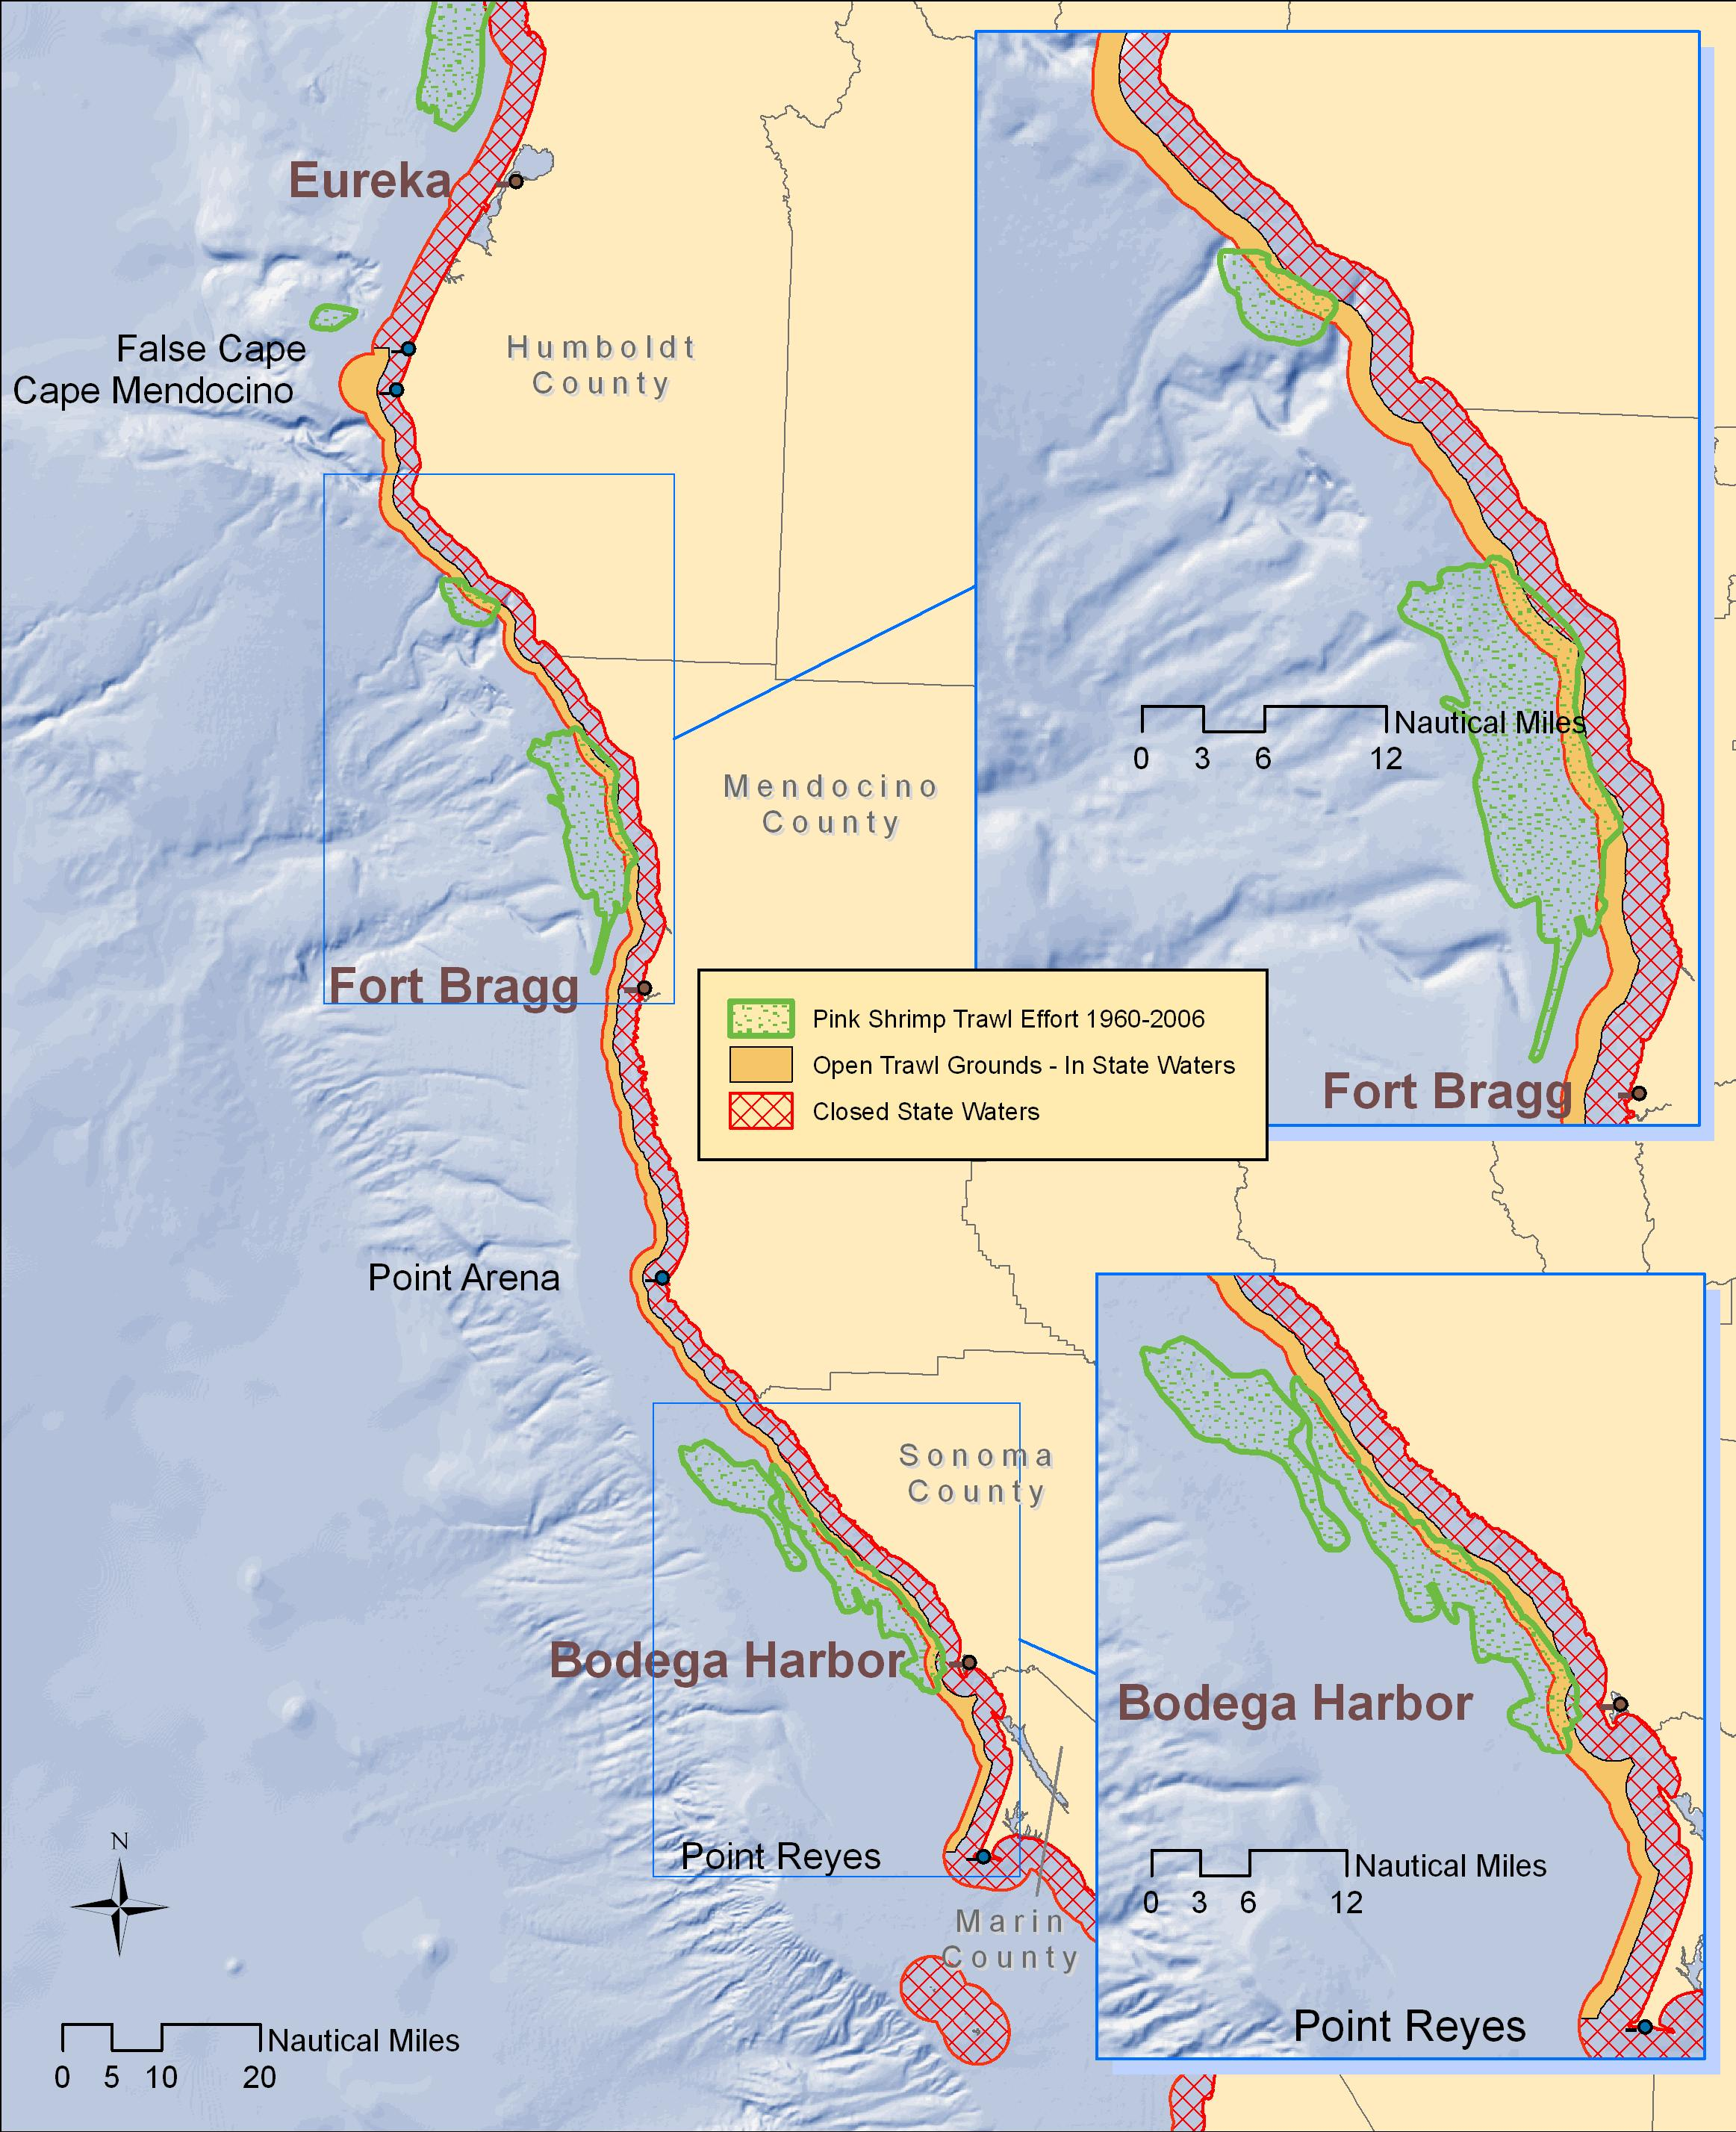
Figure 1. Historical pink shrimp trawl effort from 1960 to 2006 showing the main shrimp beds off the coast of northern California. Inset maps show the trawl effort from 1960 to 2006 in the three beds within the pink shrimp trawl grounds. Data source: CDFG historical Annual Ocean Shrimp Reports (i.e., Administrative Reports) and pink shrimp logbooks.
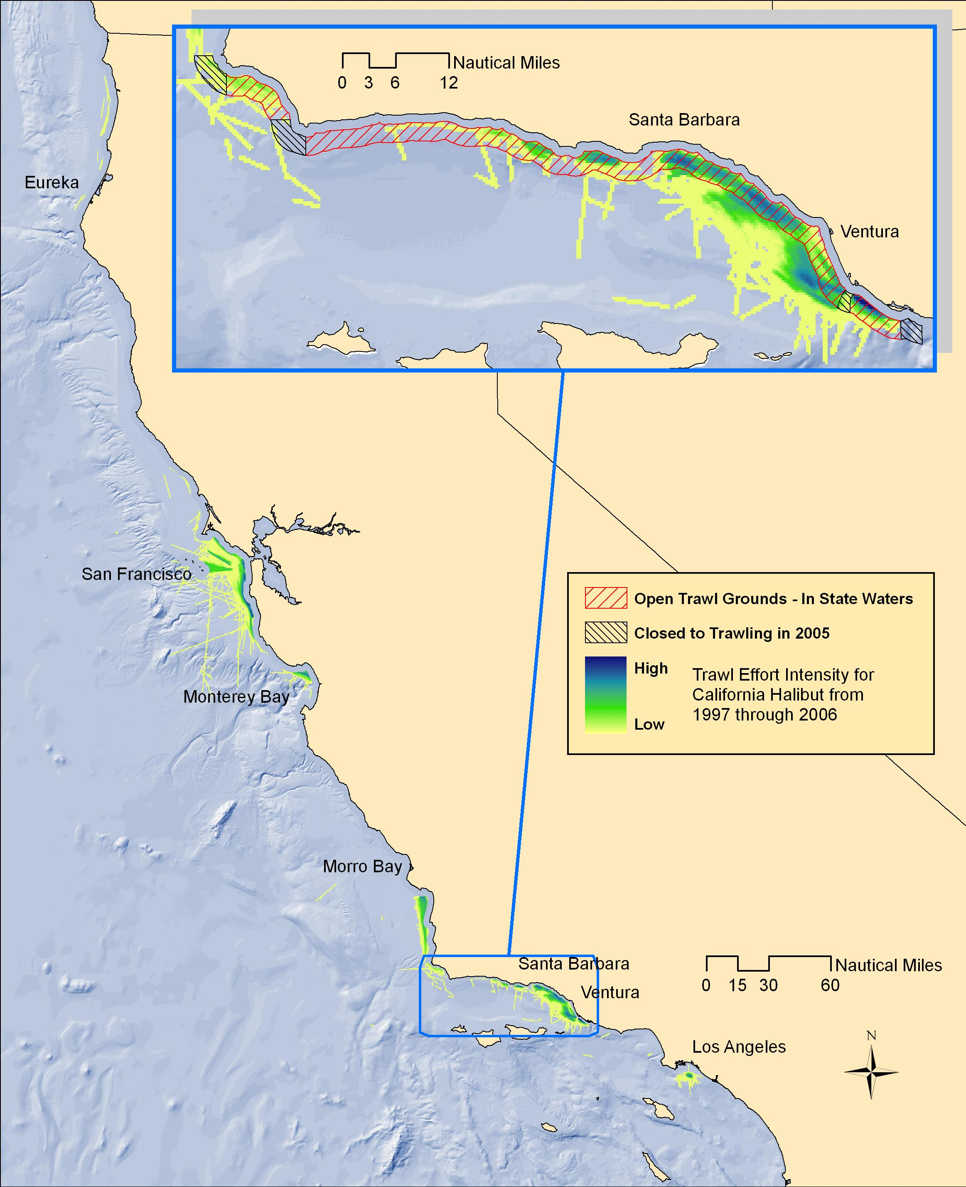
Figure 2. Historical California halibut bottom trawl effort throughout California from 1997 to 2006, including the California halibut trawl grounds which comprise state waters not less than one nautical mile from shore between Point Arguello (34° 33’ North latitude) and Point Mugu (34° 04’ North latitude).

E. OTHER ITEMS

1. Geographic Information System (GIS) Applications

The CDFG’s Marine Region maintains a large geospatial data library with a spatial extent ranging from Coastal British Columbia, Canada to Baja California, Mexico including out to 200 nautical miles offshore. The Marine Region Geographic Information Systems (GIS) Lab serves many types of data including aerial imagery, base maps (e.g., NOAA charts) bathymetric, biological, cultural, hydrological, oceanographic, topological, consumptive and non-consumptive uses and administrative boundary features. Resolutions of all data are variable, but in many cases they are very precise, including sub-meter imagery. The following are examples of categorical data holdings; they are not comprehensive lists.

Bathymetric: High resolution (less than 5 meter) multibeam bathymetry and or backscatter data are available for select portions of the coastal, Channel Islands and Farallon Islands waters. Our most recent addition (2007) includes 2 meter bathymetric soundings and imagery for the entire extent of state waters from Pigeon Point to Point Arena. Currently there are existing contracts funded by the State’s Ocean Protection Council to complete high resolution bathymetric mapping for all California State waters (0 – 3 miles). It is expected that early (southern) phases of this effort will be available by summer 2008. Additional derivate data products have been generated from backscatter and multibeam collections such as hillshades, contours, slopes, rugosity, BPI (bathymetric position indices), and benthic habitat classification maps.

Biological: Data are varied but include kelp canopies (1989, 1999, and annual surveys from 2002 to 2007), eelgrass, surfgrass, birds, mammals and natural history, observation and harvest records of many fishes and invertebrates.

Consumptive and non-consumptive use: Data for commercial and recreational activities are available. These include all recorded fisheries and some more common aquatic activities (e.g., scuba diving, kayaking, etc.) In many cases these data have been summarized by standard methods of aggregation (e.g. summarizing fisheries data by CPUE on a 1’ grid scale). Additionally, CDFG commissioned the data collection of high resolution recreational fishing, commercial fishing, and non-consumptive use activities in areas of importance for the MLPA North Central Coast Region. Similar commercial fishing areas of importance were previously collected for the Central Coast Region.

Cultural: Data provide information related to communities such as coastal access points, parks, shipwrecks, sewage outfalls, research institutions, cities, roads (and other transportation layers), ports and census information.

Physical and oceanographic: Data include rivers, lakes, watersheds, submarine features, coastal upwelling zones, coastal rocks, coastal points, islands, sea surface chlorophyll and temperature.

Spatial Management: Data showing existing MPAs, Rockfish Conservation Area closures, Cowcod Conservation Areas, military safety zone areas, administrative fishing blocks, districts, counties, state lands, state jurisdictions and kelp administrative boundaries.

Services: With widely available public spatial data to compliment our existing in-house data, the Marine Region GIS Lab analyzes trends and produces general references, such as maps, graphs and presentations to aid CDFG in planning and management decisions. Some of the higher profile projects conducted by the lab include the correlation of nearshore fish market catch to fishing block location and time, which has shown resource managers single species “hot-spots”, support of CRFS and MPA planning and monitoring with traditional and real-time GIS support. Some of the lower profile services provided by the lab are real-time simple spatial data queries and map production for all Marine Region projects.

The most current software and hardware platforms are available to support the Marine Region’s spatial analysis needs. A modern five-seat GIS lab running ESRI ArcGIS 9.2 is the primary analytical tool for spatial analysis and map production. Specific technologies within this architecture include: ArcGIS, ArcSDE, ArcIMS, ArcGIS Server, ArcInfo SQL Server 2000, Network Analyst, 3D Analyst, ArcScan, Spatial Analyst, Geostatistical Analyst, and ArcPublisher. A large format 42 inch plotter is available for printing large maps or posters for Marine Region staff.

Contributed by Paulo Serpa (831.649.7143)

APPENDIX 1:

2007 CALIFORNIA GROUNDFISH COMMERCIAL FISHERY REVIEW

The 2007 California commercial groundfish harvest (Table 3) was approximately 10.4 thousand metric tons (23.0 million pounds), with an ex-vessel value of $15.9 million. Total harvest was lower by 12.9 percent and revenue was slightly higher by 3.95 percent than comparable values in 2006, which continued a steady trend in harvest beginning in 2001. Even though the 2006 ex-vessel value was up by about 11 percent compared to 2005, it still is about 20 percent lower than the total in 2000, when approximately $20 million was generated. Total groundfish landings were nearly 25 thousand metric tons (55 million pounds) worth approximately $25 million as late as 1994.

In 2007, 87 percent of the groundfish landed was taken by bottom and mid-water trawl gear, a slight decrease from the 88 percent observed in 2006. Line gear accounted for the second largest amount at 9 percent, a very slight increase from 8.6 percent observed in 2006. The line gear contribution was at a recent peak in 1992 at 18 percent. Trap gear was 3 percent in both 2007 and 2006. Gill and trammel net landings have dropped to less than 0.5 percent because of increasingly restrictive State and Federal regulations. The major reduction in the use of gill and trammel net gear to harvest groundfish occurred in the mid-1990s; their contributions dropped from 5 percent in 1993 to 1 percent by 1996 and down to 0.4 percent in 2007.

Pacific whiting, Dover sole, sablefish and petrale sole dominated California’s 2007 groundfish harvest, making up approximately 77 percent of the state’s landings. Pacific whiting experienced a 45 percent decrease in 2007 compared to 2006, with landings of 2,968 and 5,430 metric tons, respectively. Landings of Dover sole in 2007, however, experienced a 56 percent increase from 2006. Sablefish landings decreased by 10 percent and petrale sole increased by 20 percent compared to 2006. Thornyheads and rockfishes experienced slight decreases relative to 2006.

Contributed by Bob Leos and Caroline Mcknight (831.649.2889)
Table 3. California commercial groundfish landings (metric tons) for 2007.
 | 2007 | 2006 | 2007 percent change from 2006 | 1997 | 2007 percent change from 1997
FLATFISH | 4,271 | 3,169 | + 34.8 | 8,352 | - 48.9
Dover sole | 2,759 | 1,760 | + 56.8 | 5,304 | - 48
English sole | 178 | 299 | - 40.5 | 649 | - 72.6
Petrale sole | 900 | 753 | + 19.5 | 833 | + 8
Rex sole | 171 | 149 | + 14.8 | 454 | - 62.3
Sanddabs | 157 | 115 | + 36.5 | 928 | - 83.1
Other flatfish | 106 | 93 | + 14 | 184 | - 42.4
ROCKFISH | 1,427 | 1,482 | - 3.7 | 10,193 | - 86
Thornyheads | 845 | 890 | - 5.1 | 2,810 | - 69.9
Bocaccio | 6 | 5 | + 20 | 272 | - 97.8
Canary | 1 | 2 | - 50 | 217 | - 99.5
Chilipepper | 55 | 43 | + 27.9 | 1,271 | - 95.7
Darkblotched | 41 | 21 | + 95.2 | 12 | + 241.7
Splitnose | 81 | 8 | + 912.5 | 0 | -
Widow | 8 | 8 | 0 | 1,401 | - 99.4
Black (north of 40°10') | 77 | 59 | + 30.5 | 93 | - 17.2
Minor nearshore (north of 40°10') | 21 | 17 | + 23.5 | 37 | - 43.2
Shallow nearshore rockfish  (South of 40°10') | 53 | 47 | + 12.8 | 131 | - 59.5
Deeper nearshore (south) | 36 | 37 | - 2.7 | 127 | - 71.7
Black (south) | 4 | 3 | + 33.3 | 29 | - 86.2
Ca. scorpionfish | 4 | 3 | + 33.3 | 38 | - 89.5
Other rockfish | 195 | 339 | - 42.5 | 3,755 | - 94.8
ROUNDFISH | 4,520 | 7,137 | - 36.7 | 9,945 | - 54.6
Lingcod | 78 | 64 | + 21.9 | 514 | - 84.8
Sablefish | 1,448 | 1,613 | - 10.2 | 2,940 | - 50.7
Pacific whiting | 2,968 | 5,430 | - 45.3 | 6,363 | - 53.4
Cabezon | 25 | 28 | - 10.7 | 120 | - 79.2
Kelp greenling | 1 | 2 | - 50 | 8 | - 87.5
OTHER | 252 | 244 | + 3.3 | 2,037 | - 87.6
TOTAL | 10,470 | 12,032 | - 13 | 30,527 | - 65.7
Source: California Fisheries Information System.

The commercial fishery for greenling closed August 1, 2007 for the remainder of the year, and the commercial fishery for California sheephead closed October 1, 2007 for the remainder of the year due to exceeded allocations.
The recreational fishery for federally managed groundfish was closed to boat-based anglers as of October 1, 2007 north of 37°11’North latitude due to exceeding the harvest guidelines of canary and yelloweye rockfish.

